Calze G.T S.r.l.



Via Walter Tobagi 17/19/21

46040 Casaloldo MN

ITALY

*ON MEASURE STOCKINGS*

Order of: …

### Order No.: …

Delivery: …

### Article: …………………………………………………..

### Toe: *(open or close)*……………………………………

### Leg: *(right or left)*……………………………………....

Compression Class: …………………………………...

Quantity: *(pair or piece)*…………………………….....

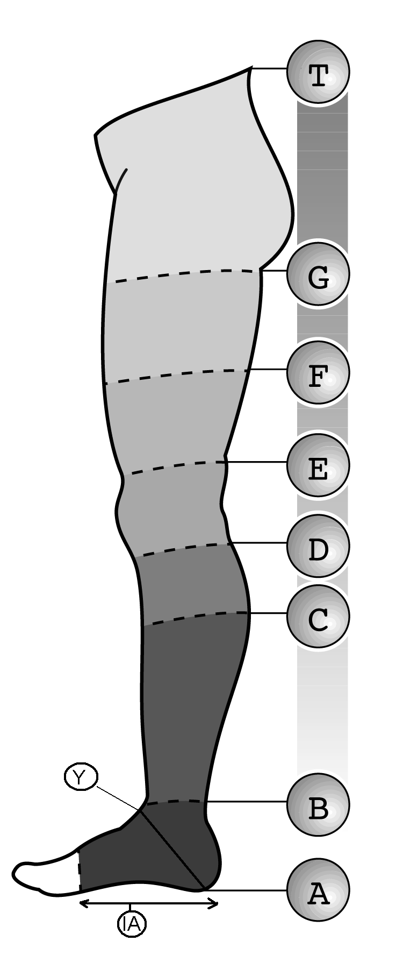

# Measure of Mr./Mrs. *(name of patient)*: ………….

### Ankle Circumference point “B” cm. …..

Calf Circumference point “C” cm. …..

### Below Knee Circumf. point “D” cm. …..

### Above Knee Circumf., point “E” cm. …..

Middle Thigh Circumf., point “F” cm. …..

Below Gluteus Circumf, point “G” cm. …..

Toe Foot Circumference, point “A” cm. …..

Instep/Heel Circumference, point “Y” cm. …..

Hips Circumference, point “L” cm. …..

Waist Circumference, point “T” cm. …..

### Measure A-B cm. …..

Measure A-C cm. …..

Measure A-D cm. …..

Measure A-E cm. …..

Measure A-F cm. …..

Measure A-G cm. …..

Measure A-T cm. …..

Measure I-A cm. …..